EENG 385 - Electronic Devices and Circuits

BJT Curve Tracer: Schmitt Trigger Relaxation Oscillator

Assembly Guide

# Assemble: Schmitt Trigger Relaxation Oscillator

This week, you will be soldering in the components associated with the SCHMITT TRIGGER RELAXATION OSCILLIATOR subsystems. This subsystem is named in Figure 1. You should solder in all the components associated with this subsystem and the resistor R10 for the RESET CIRCUIT. Table 1 lists the parts to be soldered in this week.

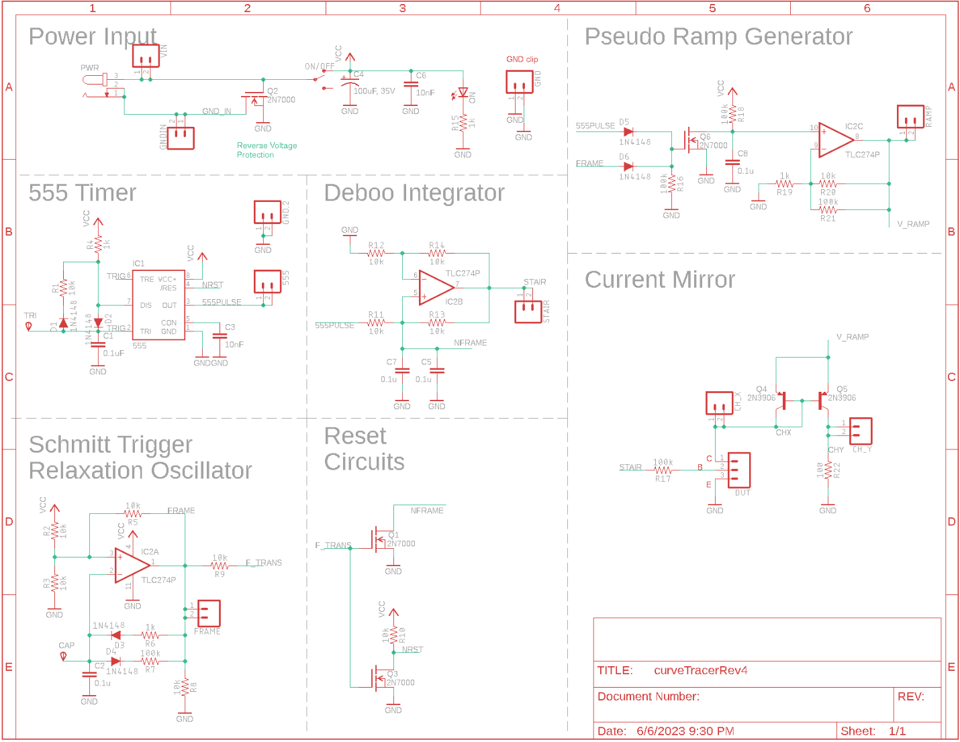

Figure 1: The schematic for the overall BJT curve tracer.

Make note of the following when assembling the Schmitt Trigger Relaxation Oscillator:

* Consider using a component tester to verify the capacitance values.
* Use a trimmed resistor lead to form the FRAME test point loop.
* This circuit has three polarized parts ‒ the pair of diodes and the TLC274. Since you are installing a socket for the TLC274, the polarity of the op amp can easily be corrected.

Table 1: List of parts to be soldered into the PCB this week. Shaded cells are polarized components. Watch their orientation.

|  |  |
| --- | --- |
| R2 / 10kΩ | TLC274 socket |
| R3 / 10kΩ | R7 / 100kΩ |
| R5 / 10kΩ | C2 / 0.1 µF |
| R9 / 10kΩ | R8 / 10 kΩ |
| D3 / 1N4148 | R6 / 1k Ω |
| D4 / 1N4148 | R10/10 kΩ |

**Soldering Tips**

Work on being patient with the heat from the solder iron soaking into the PCB pad and the part leads. Use a small dab of liquid solder on the tip of the iron to facilitate heat transfer. When everything is nice and hot, the small dab of solder will wick onto the PCB pad and component lead. When this happens, start to melt a small length (less than the join will need) into the interface between the iron tip and the component and PCB pad. Remove the solder while leaving the soldering iron tip in place to make a quick appraisal: Can the joint can take a little more solder? If so, add another little dab of solder. When done, remove the solder first, then the iron. When you get the knack of it, this should take about 5 seconds. Work on improving your work from last week – take your time.

When complete, your BJT Curve Tracer board should look like Figure 2. Note, I have installed the op amp into the socket.

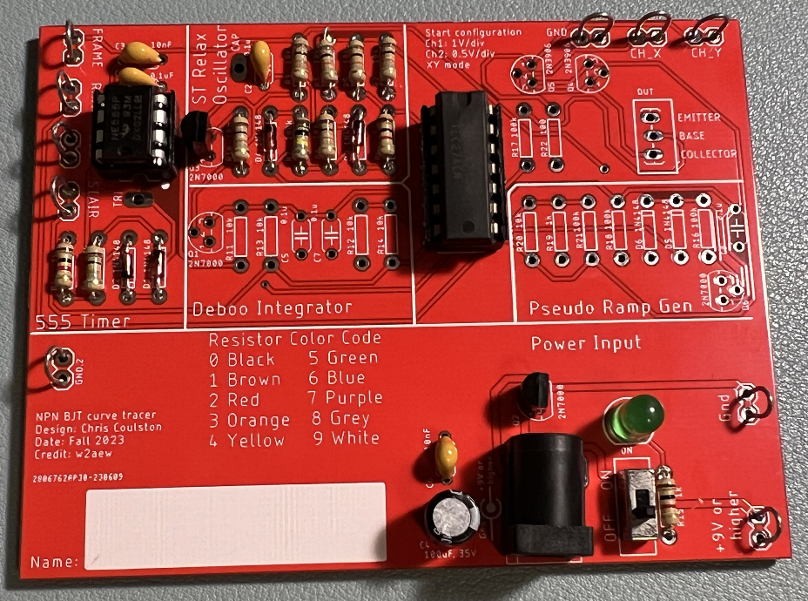

Figure 2: The completed (for Lab 2) BJT curve tracer board. Note, this board is an older version of the board with a 47 kΩ resistor in the place where you should install the 33 kΩ resistor.

After you solder in all the components, you should test and correct any problems.

# Test: ST RELAX OSCILLATOR

1. Check the resistance between the “+9V or higher” and “Gnd” test points with the ON/OFF switch in the OFF position. You should get an overload condition on the DMM – there is essentially infinite resistance with the switch in the OFF position.
2. Check the resistance between the “+9V or higher” and “Gnd” test points with the ON/OFF switch in the ON position. This measurement jumps around and may show negative resistance. The value displayed is not meaningful.
3. Power up the BJT curve tracer:
   * Put the ON/OFF switch in the OFF position,
   * Apply power to the board either through your AC/DC converter or using the lab power supply. If you are using the lab power supply, set the voltage to 9V and the current to 100 mA.
   * Put the ON/OFF switch to the ON position.
   * The green LED should illuminate.
4. Power up an oscilloscope. Attach a probe to Channel 1 and configure it as follows.

|  |  |
| --- | --- |
| Ch 1 probe | FRAME test point |
| Ch 1 ground clip | GND test point |
| Horizontal (scale) | 1 ms |
| Ch 1 (scale) | 1 V or 2 V (whatever fits better) |
| Ch 2 probe | Inverting input of op amp |
| Ch 2 (scale) | Same as Channel 1 |
| Trigger mode | Auto |
| Trigger source | Ch1 |
| Trigger slope | ↑ |
| Trigger level | 4.5V |

Set the GND reference of Ch 1 and Ch 2 to the lowest visible reticule – the waveforms will overlap the same as they did in the MultiSim simulation. Set the horizontal position of the trigger to the left most visible reticule. Note, the op amp output is sent to the FRAME test point. The capacitor charge is available by attaching an oscilloscope probe to the CAP test point shown in Figure 8.

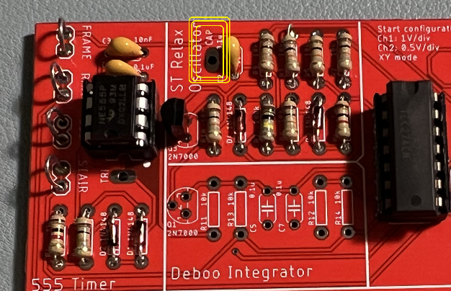

Figure 3:You can probe the capacitor voltage at the yellow circled test point.

After you get everything setup, take a screen shot of the *Vout* and *Vcap* waveforms to include in your lab report. You may want to apply the Acquire function to average 32 waveforms together to smooth the waveforms. Use the data collected from the oscilloscope to fill out the **Assemble** columns in **Error! Reference source not found.**, and **Error! Reference source not found.**.

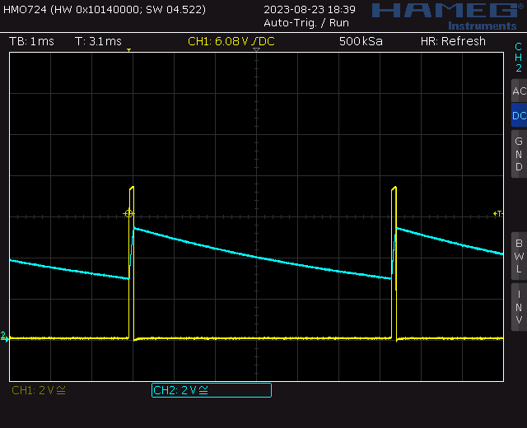

Note, this oscilloscope trace was captured on a Rhode&Schwarz HMO724.

**Debugging ST RELAX OSCILLATOR Subsystem**

I would expect most problems with this subsystem to be the result of:

* Bad solder connection
* Diodes soldered in backwards
* Wrong component (resistor or capacitor)

If your BJT curve tracer board fails one of the test steps in the previous section, here is some guidance on what may have happened and how to correct it.

1. If you are getting low resistance with the ON/OFF switch in the OFF position:
   * Make sure the ON/OFF switch is in the OFF position.
   * Check for solder bridges on the rear of your PCB.
   * Make sure you are reading the DMM correctly. The reading when the ON/OFF switch in the OFF position should be the same as when you hold the probes apart in air.
2. If you are getting a different resistance with the ON/OFF switch in the ON position:
   * Make sure the ON/OFF switch is in the ON position.
   * Make sure you are reading the DMM correctly. The reading when the ON/OFF switch in the ON position will jump around a lot and probably be negative.
3. If the green LED does not illuminate when power is applied to the ON/OFF and the switch is in the ON position:
   * Test power is supplied. Put a DMM in voltage mode and check the +9V and Gnd test points.
   * Check for solder bridges on the rear of the PCB.
4. If you are not getting waveforms resembling the MultiSim Live simulation:
   * Test that the board is powered up.
   * Check the oscilloscope leads are fully inserted.
   * Press the “Default Setup’” button to undo any weird configuration the last user may have left the oscilloscope in.
   * Check solder connections by trying to wiggle each component. No visible movement should be possible.
   * Check all pins of the TLC274 are firmly engaged into the IC socket.